MongoDB REPLICA SET
The client application always communicates with the primary node of MongoDB.
MongoDB has amaximum of 1 Primary node and the default structure has 2 secondary nodes which are "Backups of the primary"
everything what happens on our database is registered in OpLOG (operation log).
Secondary nodes will get the OpLOG from the Primary node and then apply the transactions to its own datasets (Even secondary databases have its own dataset).
The 2 Secondary nodes are used for disaster recovery, so this instancess need to be run in different machines.
The Secondary nodes can replicate also from another Secondary nodenot only from the Primary.
If The Primary node fails, one of the Secondary nodes will now be elected to be the primary node.
If the Primary node is overloaded with write/read operations we can also spread the Read operations to the Secondary nodes, and let Primary node deal only with the Write operations.

MongoDB Replication Setup on Windows

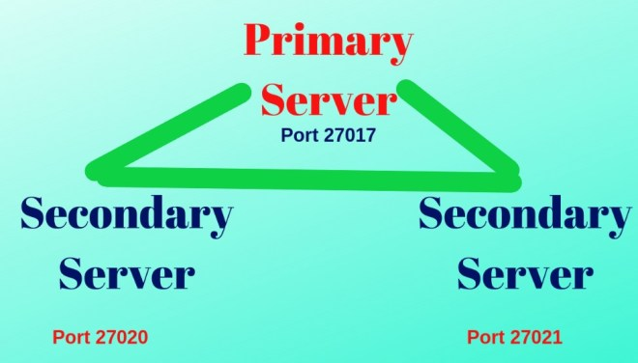

Primary Server: Making standalone as primary server with no: 27017
Secondary Servers: Started two servers with port numbers: 27020 and 27021

Create 2 folders data1 and data2 and 3 subfolders config, db, log like in img >
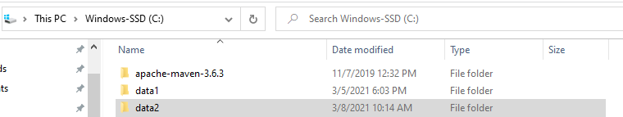

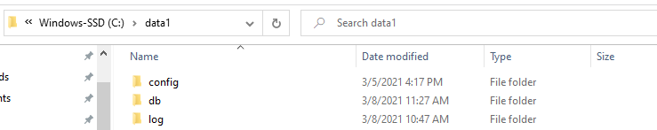

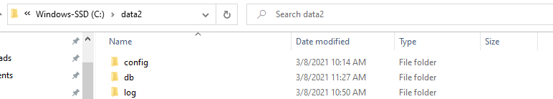

At the folder config we should made the file "mongo" with specific configurations:
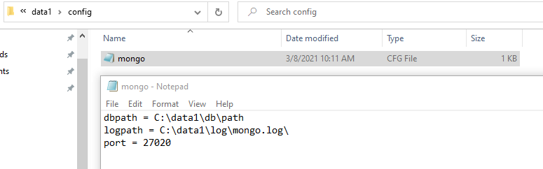

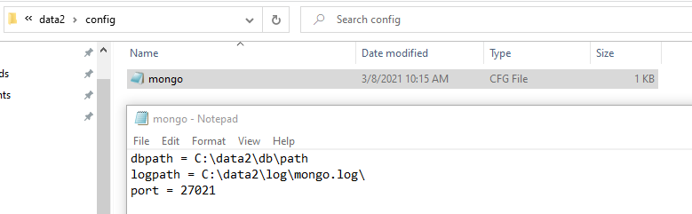

Those configurtions are for the SECONDARY (slave) servers because the PRIMARY (master) server has by default at MongoDB folder (C:\Program Files\MongoDB\Server\4.4\bin) the configurations for (“localhost:27017”) port.
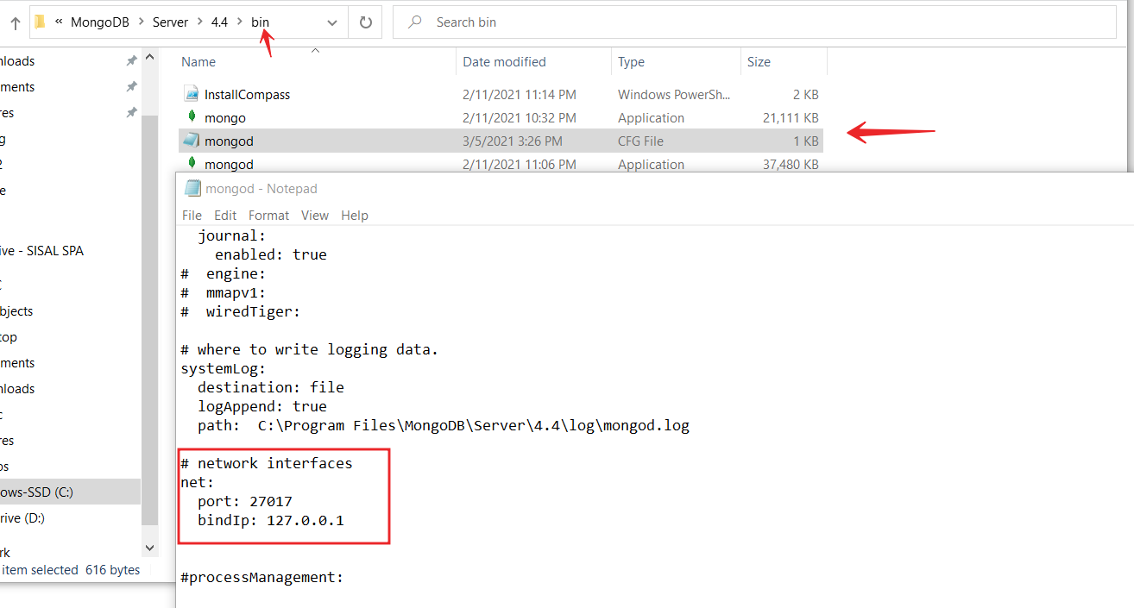

After that to make the configurations for this mongoDB replica set in Windows we should made configurations directly on cmd like (“Run like administrator”)

- Start standalone server as shown below, this will be the MASTER node.

mongod --dbpath "C:\Program Files\MongoDB\Server\4.4\data" --logpath "C:\Program Files\MongoDB\Server\4.4\log\mongod.log" --port 27017 --storageEngine=wiredTiger --journal --replSet r2schools

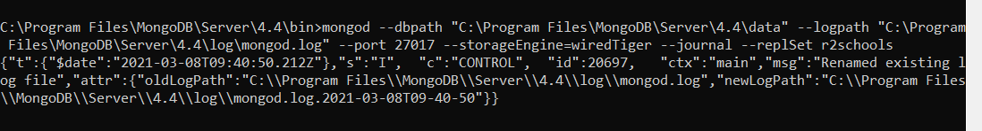

- Start secondary server number 1 on the port 27020.
mongod --dbpath "C:\data1\db" --logpath "C:\data1\log\mongod.log" --port 27020 --storageEngine=wiredTiger --journal --replSet r2schools

- Start secondary server number2 on the port 27021.
mongod --dbpath "C:\data2\db" --logpath "C:\data2\log\mongod.log" --port 27021 --storageEngine=wiredTiger --journal --replSet r2schools
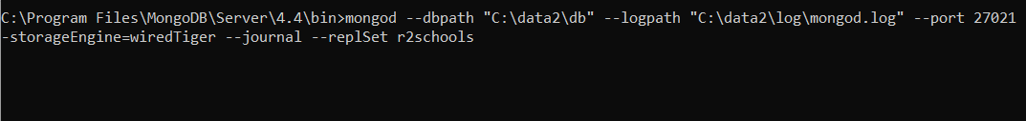

After that we have started the PRIMARY server and the 2 of the SECONDARY servers.

- Connect to the server with port number 27017
mongo --port 27017

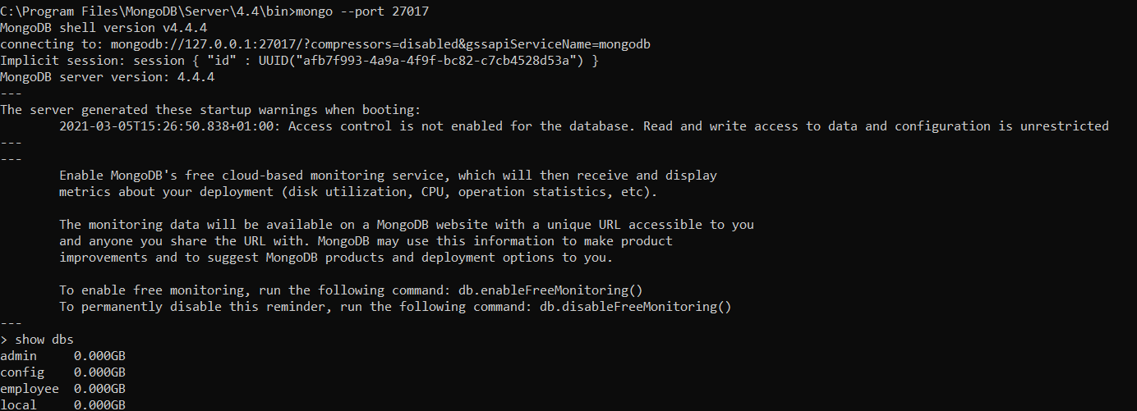

- Logon to secondary servers with:
mongo --port 27020
mongo --port 27021

- Then, create variable rsconf.
rsconf={_id:"r2schools",members:[{_id:0,host:"localhost:27017"}]} rs.initiate(rsconf)

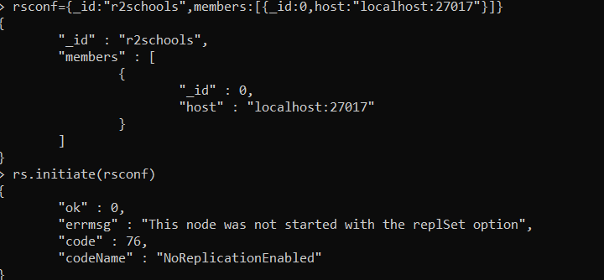

Here I had an error because I was connected already to older server and I cant connect to the new one . For that I follow that solutions on StackOverflow >
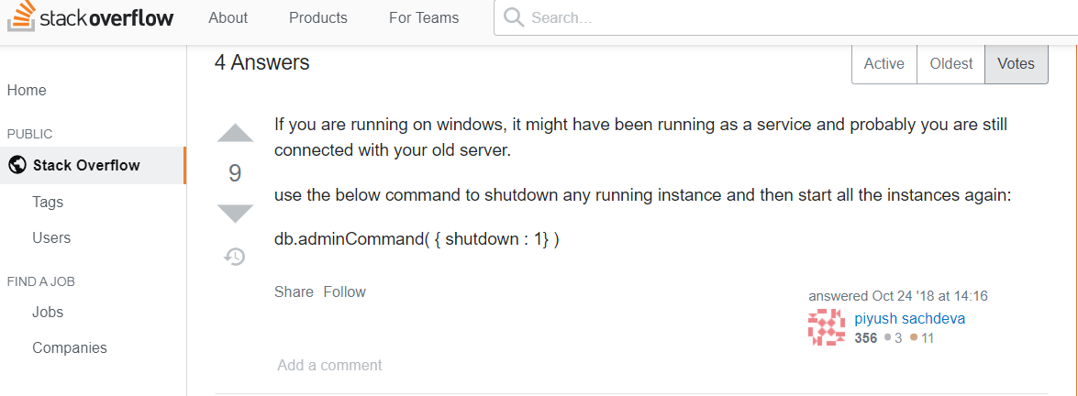

And works perfectly for me 😊 !!!

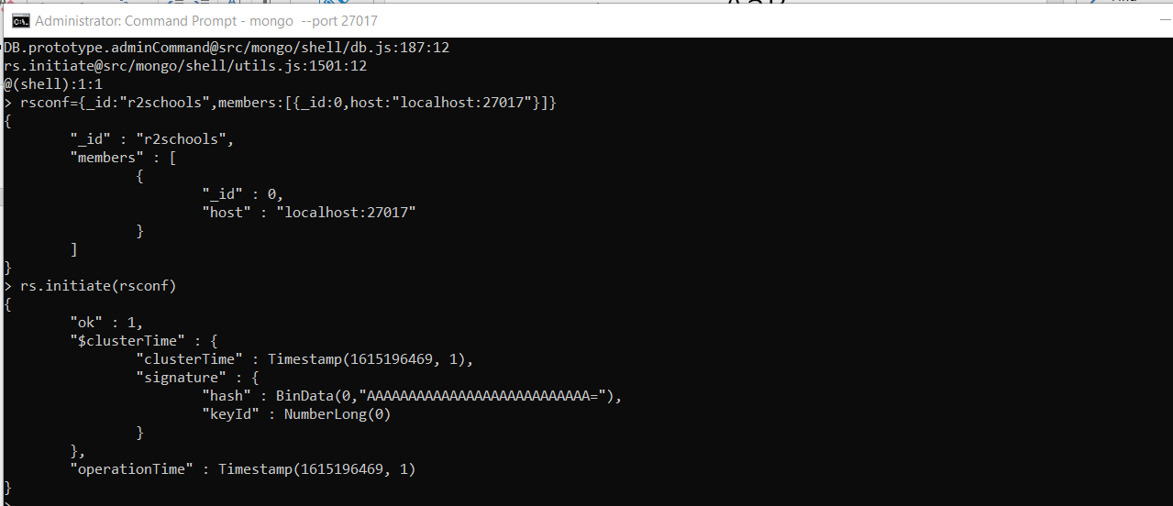

And now is created the replica configuration on a single windows machine. We have three different machines , with name , IP address and port number, for that should made configuration in all of three machines. For that we should add in PRIMARY server those commands :

rs.add("localhost:27020") rs.add("localhost:27021")

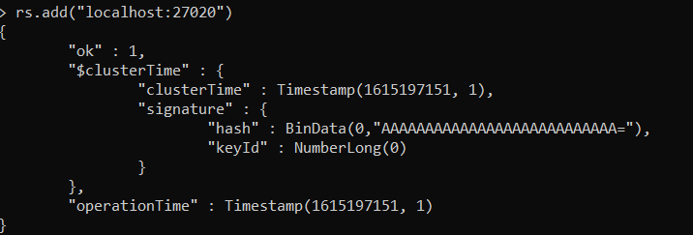

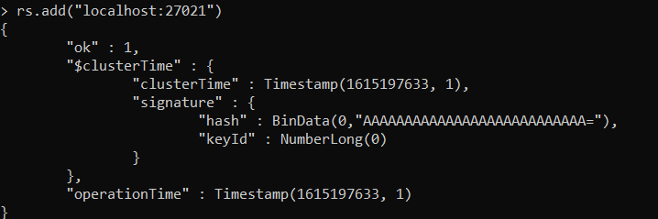

You cant do the show dbs on slave server , for that should made that configuration:
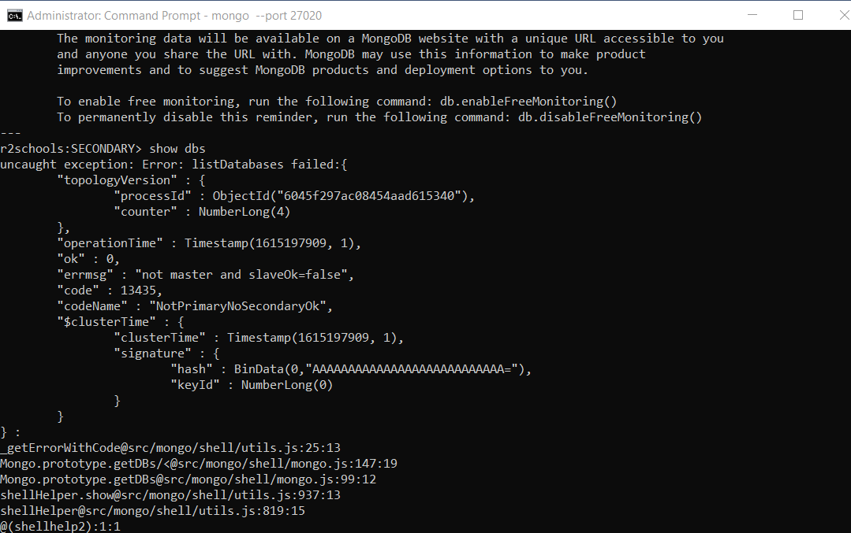

- On the SECONDARY servers we should run below command :
rs.slaveOk()

Here I had an issue because I used the new version of MongoDB 4.4 and this command is for version less tha 4.2 , for versions after 4.2 MongoDB will suggest you that :
rs.secondaryOk()

- On that point we can see and the status for each machine :

rs.status

and here I had an issue and resolved like that :
> rs.status
function() {
return db._adminCommand("replSetGetStatus");}

Used this
> db.adminCommand( { replSetGetStatus: 1, initialSync: 1 } )

And the OUT was that :
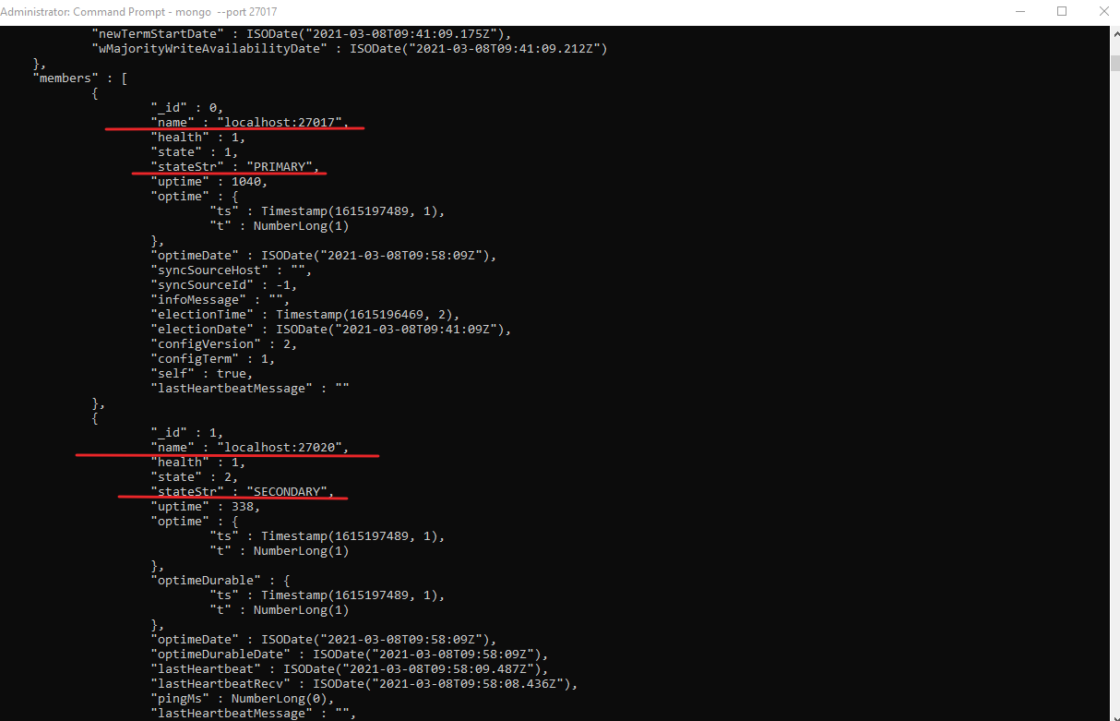
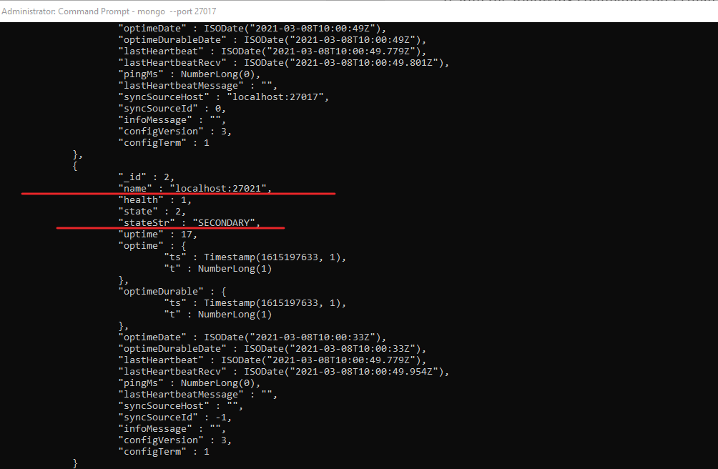

10. But you can verify and with command
> rs.isMaster()

And get this for PRIMARY :
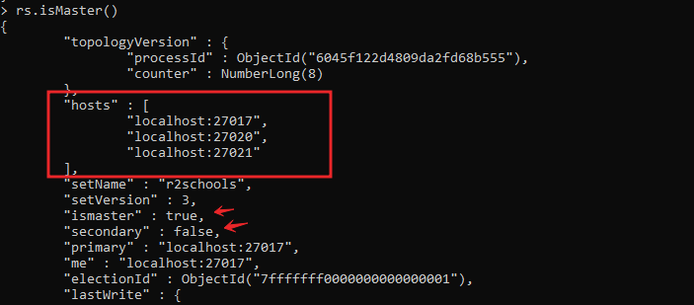

And this for 2 SECONDARY servers :
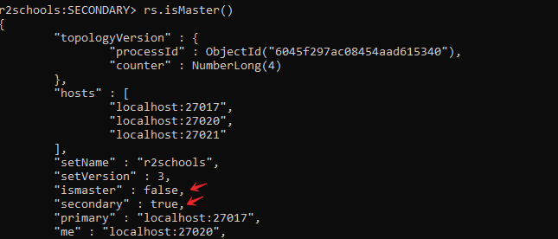

- After that we should verify if our Replica Set work or not : we will create on master for that a db and insert into collection a document .
With following commands :

- - create db with :

> use sisal

- - put info document (create document):

> employee = {"Name":"Drilon","ID":1,"Date":new Date()}

OUT:\
{
"Name" : "Drilon",
"ID" : 1,
"Date" : ISODate("2021-03-05T14:49:58.874Z")
}

- - insert (employee) document on [db sisal] - (collection) :

> db.sisal.insert(employee)

out:\

WriteResult({ "nInserted" : 1 })

- - read this document , who we inserted on collection (db sisal):

> db.sisal.find()

out"\

{ "_id" : ObjectId("604245a924ac2341fd53feae"), "Name" : "Drilon", "ID" : 1, "Date" : ISODate("2021-03-05T14:49:58.874Z") }

- - how to update:

create a value to update the document:

> employee.location = "London"

out:\
London

update the document with the valued created:

> db.sisal.update({Name : "Drilon"},employee)

out:\
WriteResult({ "nMatched" : 1, "nUpserted" : 0, "nModified" : 1 })

- -read the update:

> db.sisal.find()

out:\
{ "_id" : ObjectId("604245a924ac2341fd53feae"), "Name" : "Drilon", "ID" : 1, "Date" : ISODate("2021-03-05T14:49:58.874Z"), "location" : "London" }

- - delete the document created on db collection:
> db.collection.remove()

- All that should appear on Master and on Slave too:
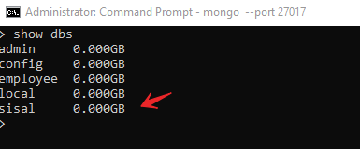

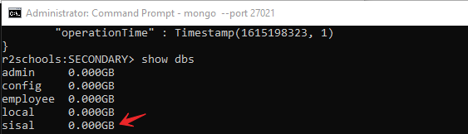

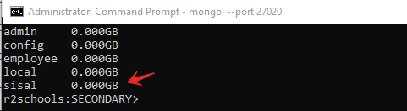

- But and in the end we should try to test the write (just Primary)/read( the Secondary)

For that we should try to insert in secondary server to the collection we have created on Primary. And get this :

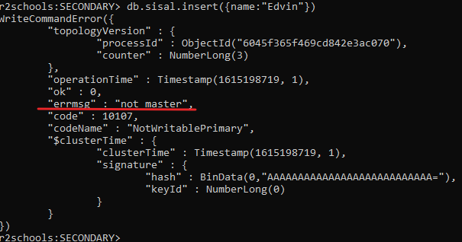

MongoDB cluster for data replication using docker-compose
On this part of Demo I have shown how to write docker compose file to create simple mongodb cluster for data replication.
- For the first we should create a directory when we should made the configurations and when we put our docker-compose.yml
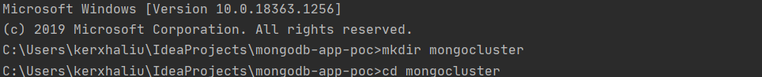
- Before all configurations we should verify if we have installed docker and docker compose on our machine https://www.docker.com/products/docker-desktop
https://docs.docker.com/compose/install/
- To continue on that we should create a file on our directory with name docker-compose.yml and open on editor (im using like editor Intellij)
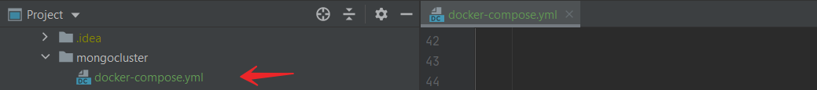
- The most cruisial step on those configurations is composing the file docker-compose.yml .
version: '3'
services:
node1:
image: mongo
ports:
- 30001:27071
volumes:
- C:\mongoclusterdata\node1:\data\db
networks:
- mongocluster
command: mongod --replSet comments
node2:
image: mongo
ports:
- 30002:27071
volumes:
- C:\mongoclusterdata\node2:\data\db
networks:
- mongocluster
command: mongod --replSet comments
depends_on:
- node1
node3:
image: mongo
ports:
- 30003:27071
volumes:
- C:\mongoclusterdata\node3:\data\db
networks:
- mongocluster
command: mongod --replSet comments
depends_on:
- node2
networks:
mongocluster:
driver: bridge

some commands we have used on yml file are:
- version: '3' ( version of docker-compose file)
- services: (here we config our containers)
- node1: node2: node3: (our containers)
- image: mongo (I have used a basic image provided from docker hub)
- ports:
- 30001:27071
- 30002:27071
- 30003:27071
( here I will assign the ports , the port 27071 is the port inside docker container and the port 30001,30002,30003 are the public ports exposed to the world )
- volumes:
- C:\mongoclusterdata\node1:\data\db
- C:\mongoclusterdata\node2:\data\db
- C:\mongoclusterdata\node3:\data\db
( here we make the mapping off DB path :\data\db from docker container to our C:\mongoclusterdata\node local machine, if is not created a folder in our machine with that path , it will be created automatically when the docker-copose.yml it will be run)
- networks:
- mongocluster
(here im going to create a network with that name)
- command: mongod --replSet comments (the following command makes the replica set between our containers and the command --replSet is mandatory , and the name is comments)
- depends_on:
- node1
- node2
(the depends_on is the commands we used to make order run-create for our containers after the node2 is created it will be run the node3)
- networks:
mongocluster:
driver: bridge
(I have concluded all three of our containers on the same network)
after created the docker-compose.yml file we should try to run on terminal that command

- After we should run that docker-compose.yml file on terminal
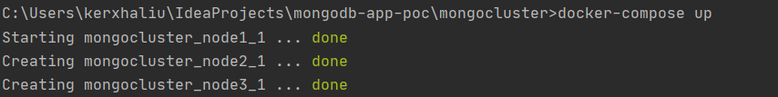
We will create our 3 containers like we have specified in our yml file. To verify that should go on terminal and try with docker ps

ERRORS:
Here at this points you may have some usually errors or problems , me I have some errors but two most inportants I resolved in that way
1.
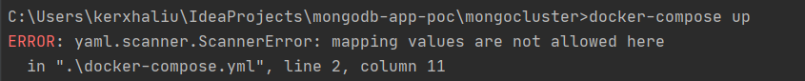
This error is because we shouldn’t create an .yml file with all standarts on writing the comends , we doesn’t have respect the logic on writing the services, nodes and ect…
I have resolved and adjusted this trying on this emulator : http://yaml-online-parser.appspot.com/
2.
This error it comes because I had on port number 3001 runned another old container, for that I stoped the old container and runed my new node1 container or if you want you can use other ports on public appear like 40001 ect..

- After we have created our three containers , we made the first one node PRIMARY (master) and 2 others node2 and node3 SECONDARY (slaves) with command : rs.secondaryOk()
- Here we can try to insert in a DB (test) a collection (mycollection) with a document and try to se if the logic of replica write(master)/read(slave) it works.
- Execute mongo on each container:
mongodb-app-poc>docker exec -it mongocluster_node1_1 mongo
mongodb-app-poc>docker exec -it mongocluster_node2_1 mongo
mongodb-app-poc>docker exec -it mongocluster_node3._1 mongo
- Assign on db test : db = (new Mongo('localhost:27017')).getDB('test')
- Config​ for connecting three nodes together (execute this from master node):
config = {
"_id": "comments",
"members": [
{
"_id": 0,
"host": "node1:27017"
},
{
"_id": 1,
"host": "node2:27017"
},
{
"_id": 2,
"host": "node3:27017"
}
]
}

- Config replica: > rs.initiate(config) 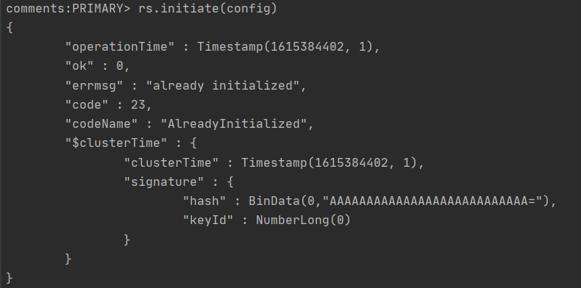
- Insert a document to mycollection on our db, from PRIMARY node1:
- Try to update from slave node (container) the same document :

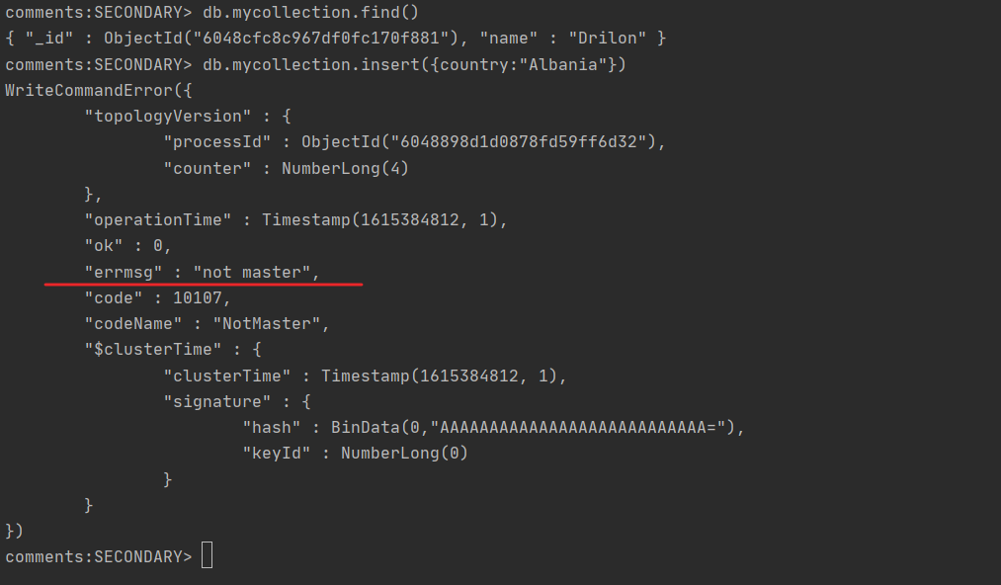

Overload and test MongoDB replicaSet using JMeter
First install Apache JMeter (5.4.1). We will need also to add under C:\apache-jmeter-5.4.1\lib 2 jar files groovy-2.4.4 and mongo-java-driver-3.8.0. To run this tool you should navigate inside its /bin folder and open ApacheJMeter executable file. The tool will start.
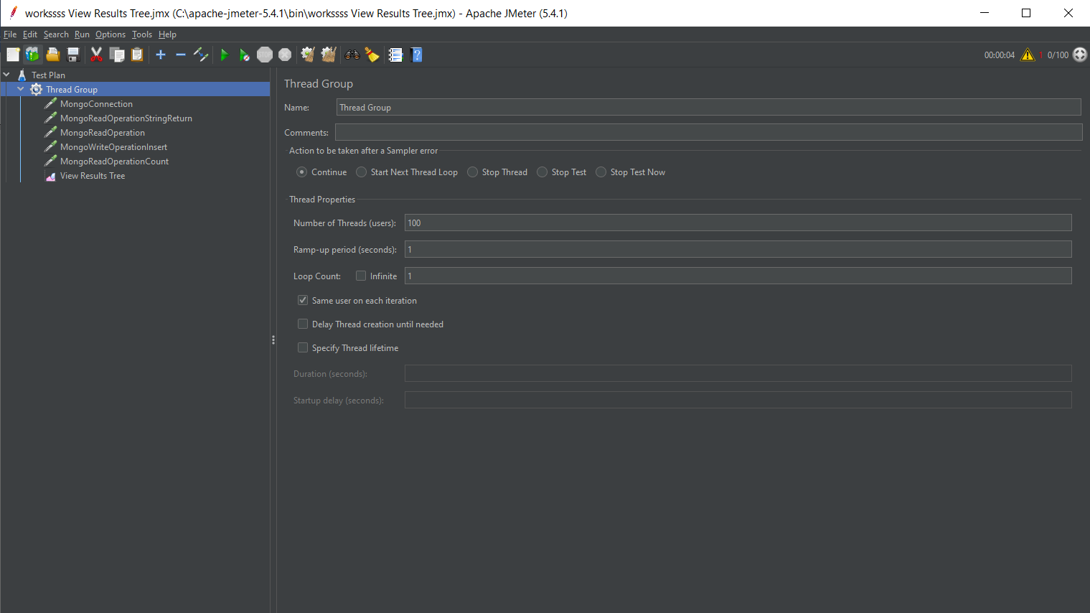
On the left, under Test plan we can create our tests. First, we need to create a Thread group (TestPlan -> add -> Threads -> ThreadGroup) and then under the ThreadGroup we create the tests we want to try (ThreadGroup -> add -> Sampler -> JSR223 Sampler).
On the Test Plan we add the host, port and credentials of our database as showed in the photo.
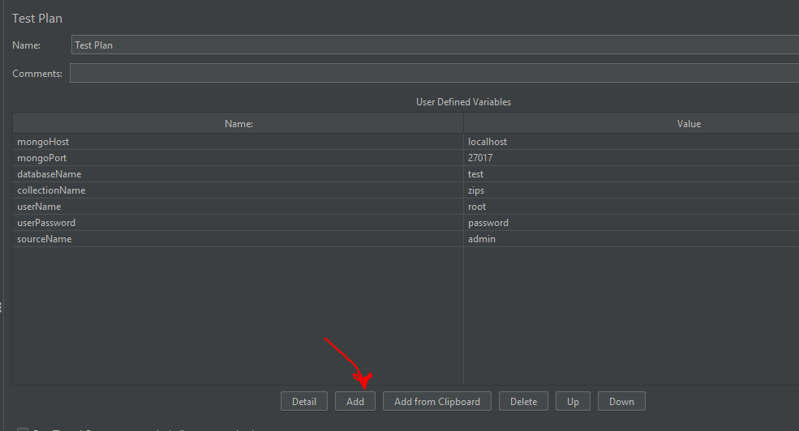
On ThreadGroup we can specify the number of operations executed in parallel against our DB. In this case im trying 100 operations.
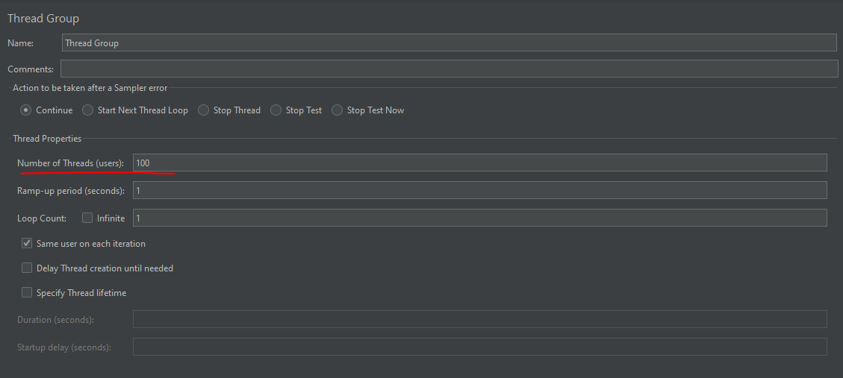
Now we will continue creating the tests for our database. First of all I will create a two tests to connect to our Primary database and Secondary database.
We need to add two JSR223 Sampler files under our Thread Group. ThreadGroup -> add -> Sampler -> JSR223 Sampler
Rename them as MongoConnection and MongoConnectionSecondary and use the below groovy script for both of them, but change just the port on MongoConnectionSecondary so it will point to the secondary database. Also at the return statement make sure to add a label “SECONDARY and PRIMARY” so we can understand from the response on which database we performed the operation.
import com.mongodb.* import com.mongodb.client.MongoClients; import com.mongodb.client.MongoClient; import com.mongodb.MongoClientSettings; import com.mongodb.ServerAddress; import com.mongodb.client.MongoCollection; import com.mongodb.client.MongoDatabase; import org.bson.Document; import java.util.Arrays;
try {
MongoCredential credential = MongoCredential.createCredential("root", "admin", "password".toCharArray());
MongoClientSettings settings = MongoClientSettings.builder()
.applyToClusterSettings {builder ->
builder.hosts(Arrays.asList(new ServerAddress( vars.get("mongoHost"), vars.get("mongoPort").toInteger())))}
.credential(credential)
.build();
MongoClient mongoClient = MongoClients.create(settings);
MongoDatabase database = mongoClient.getDatabase(vars.get("databaseName"));
MongoCollection<Document> collection = database.getCollection(vars.get("collectionName"));
vars.putObject("collection", collection);
return " PRIMARY /SECONDARY : Connected to " + vars.get("collectionName");
}
catch (Exception e) {
SampleResult.setSuccessful(false);
SampleResult.setResponseCode("500");
SampleResult.setResponseMessage("Exception: " + e);
}

MongoConnection RESPONSE: PRIMARY: Connected to zips, Response code: 200, Response message:OK
MongoConnectionSecondary RESPONSE: SECONDARY: Connected to zips, Response code: 200, Response message:OK

We can also Create two new JSR223 Sampler and create two Read Operations. Rename the JSR223 Sampler files to MongoReadOperation and MongoReadOperationSecondary and use the below groovy script. Make sure to add a label “SECONDARY and PRIMARY” so we can understand from the response on which database we performed the operation.
import com.mongodb.client.MongoCollection; import static com.mongodb.client.model.Filters.*; import org.bson.Document; import org.bson.types.ObjectId;
try {
MongoCollection<Document> collection = vars.getObject("collection");
Document result = collection.find(eq("city", "BABYLON")).first();
vars.put("exampleDocumentId", result.get("_id").toString());
return “PRIMARY/SECONDARY” + result;
}
catch (Exception e) {
SampleResult.setSuccessful(false);
SampleResult.setResponseCode("500");
SampleResult.setResponseMessage("Exception: " + e);
}

MongoReadOperation RESPONSE: PRIMARY:[_id:604b94c805ae4896e8e49d76, city:DURRES, loc:[32.2111, 44.2515], pop:300000, state:IS]
Response code: 200, Response message:OK
MongoReadOperationSecondary RESPONSE: SECONDARY:[_id:604b94c805ae4896e8e49d76, city:DURRES, loc:[32.2111, 44.2515], pop:300000, state:IS]
Response code: 200, Response message:OK

In the same way we can create an insert operation. Create a new JSR223 Sampler and rename it to MongoWritteOperationInsert and use the below groovy script
import com.mongodb.* import com.mongodb.client.MongoCollection; import com.mongodb.BasicDBObject import org.bson.* import static com.mongodb.client.model.Filters.*; import org.bson.Document; import org.bson.types.ObjectId; import org.apache.jmeter.protocol.mongodb.config.MongoDBHolder;
try {
ServerAddress server = new ServerAddress("localhost", 27017)
MongoCredential credentials = MongoCredential.createCredential("root", "admin", "password".toCharArray())
MongoClient mongoClient = new MongoClient(server, Arrays.asList(credentials));
DB db = mongoClient.getDB("test");
DBCollection collection = db.getCollection("zips");
BasicDBObject object = new BasicDBObject();
BasicDBList location = new BasicDBList();
location.add(32.211100D);
location.add(44.251500D);
object.append("city","BABYLON");
object.append("loc",location);
object.append("pop",300000);
object.append("state","IS");
WriteResult result = collection.insert(object);
}
catch (Exception e) {
SampleResult.setSuccessful(false);
SampleResult.setResponseCode("500");
SampleResult.setResponseMessage("Exception: " + e);
}

RESPONSE: WriteResult{n=0, updateOfExisting=false, upsertedId=null}
Response code: 200, Response message:OK

Under our ThreadGroup we can add a file View Results Tree using ThreadGroup -> add -> Listener -> View Results Tree
Now we can run and see the results on View Results Tree. See the photo below.
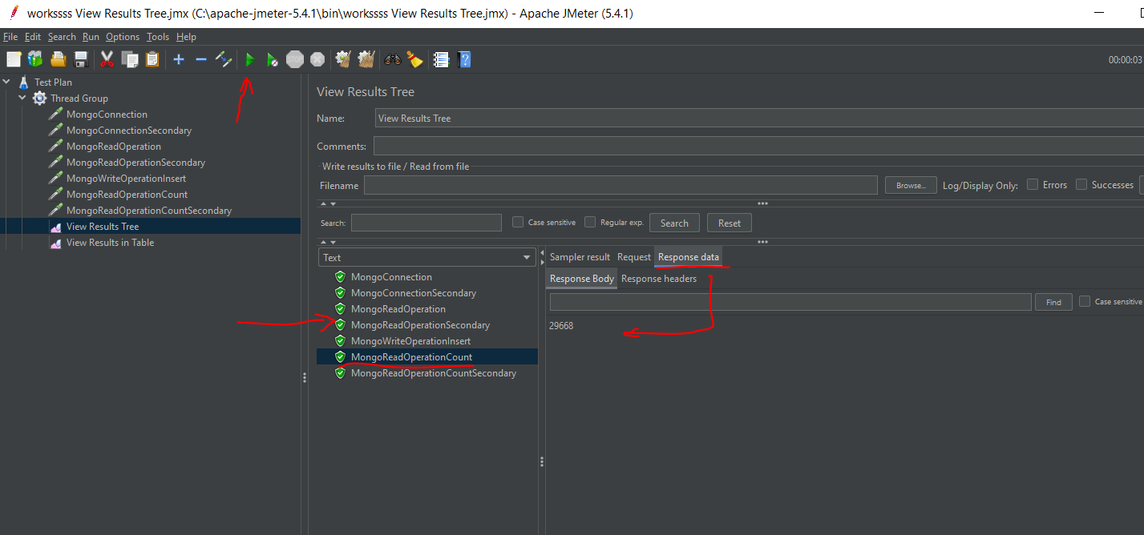

As we can see all the tests on 2 databases are working correctly, we can see also the number of the records in both databases MongoReadOperationCount and MongoReadOperationCountSecondary . We can say that the replication is working correctly because the number of elements is the same also the result of the read operation is the same. We can also try to query the new record we inserted on the primary database and see that it also is present on the Secondary database.
If we set the number of threads of the Thread Group to 100 we will see that each test is executed 100 times.

THANK YOU 😊 !

